ProQuest- Submission Instructions
- Enter ETD Website (https://www.etdadmin.com/) Create your account.
- At the top, blue banner, click “Create New Submission”
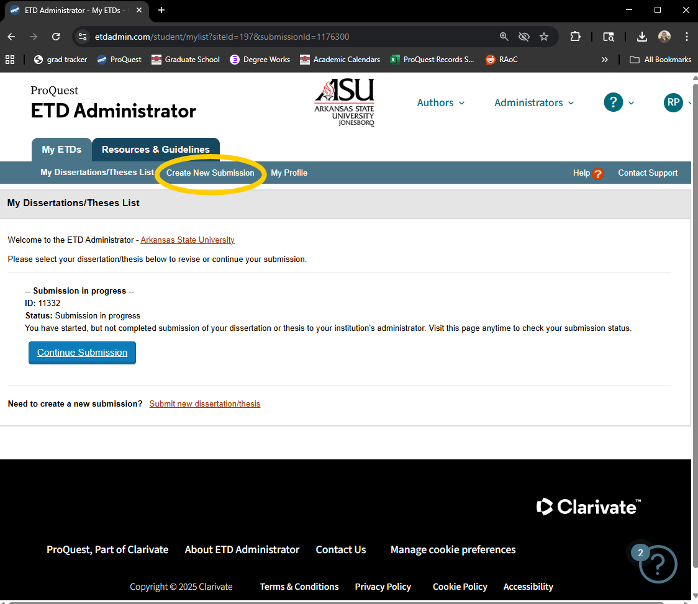

- Complete steps on left side of screen. ProQuest will walk you through each step.
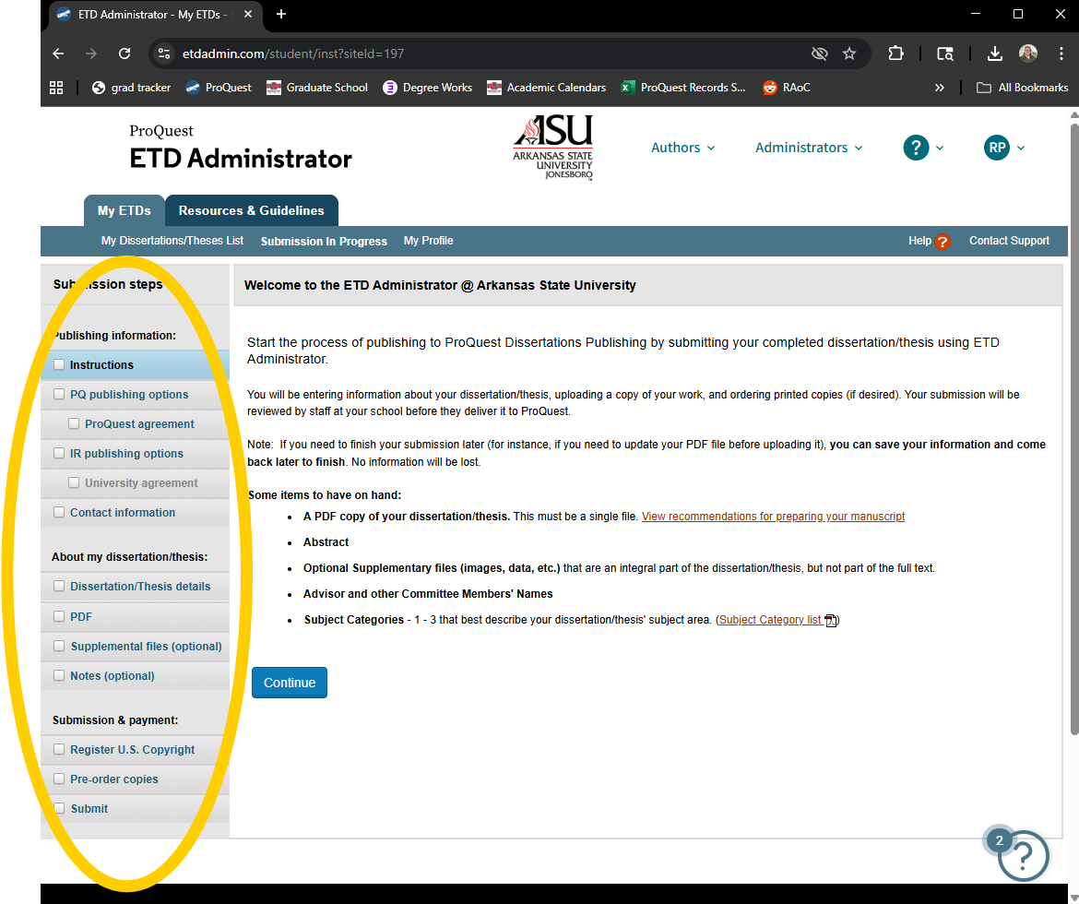

- PQ Publishing Options:
PQ offers two publishing options—one free and one paid. We advise that if you are planning to continue publishing or working in your field, or continue your education, select the paid publishing option. This allows others to see and find your work, especially in academic settings.

If you are at the end of your academic career or do not foresee others needing to access your document, we suggest you choose the traditional publishing option.
The A-State library has an online and physical collection of all ProQuest published documents that is free to access.
- In your contact information, make sure to use an email that you will have access to regularly. This is the email that official ProQuest publishing information will come through, as well as editing emails from the Graduate School.
- Copyrights are not required. If you choose to add a copyright to your document, there is an additional fee.
- You are required to purchase copies of your document. You must purchase at least 2 hardbound copies for the Library depository, and one for yourself, in whatever binding you choose. Make sure to verify what copies you need with your program director; some programs require copies for the committee chair and program director.
  - Currently, the hardbound copies (8.5x11in) are $62 each, for a total of $124
  - You can also return to the site later and purchase additional copies.
- Once your payment processes and you submit your document, you will receive an email confirming.
*your submission will not be complete unless you pay for your copies/copyright/publishing.

