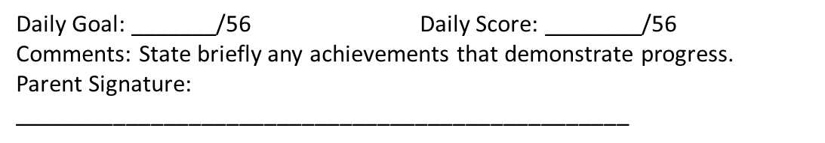

CICO Daily Progress Reports – Elementary Examples
Name: _________________________________ Date:___________

Homeroom Teacher: _____________________________________



