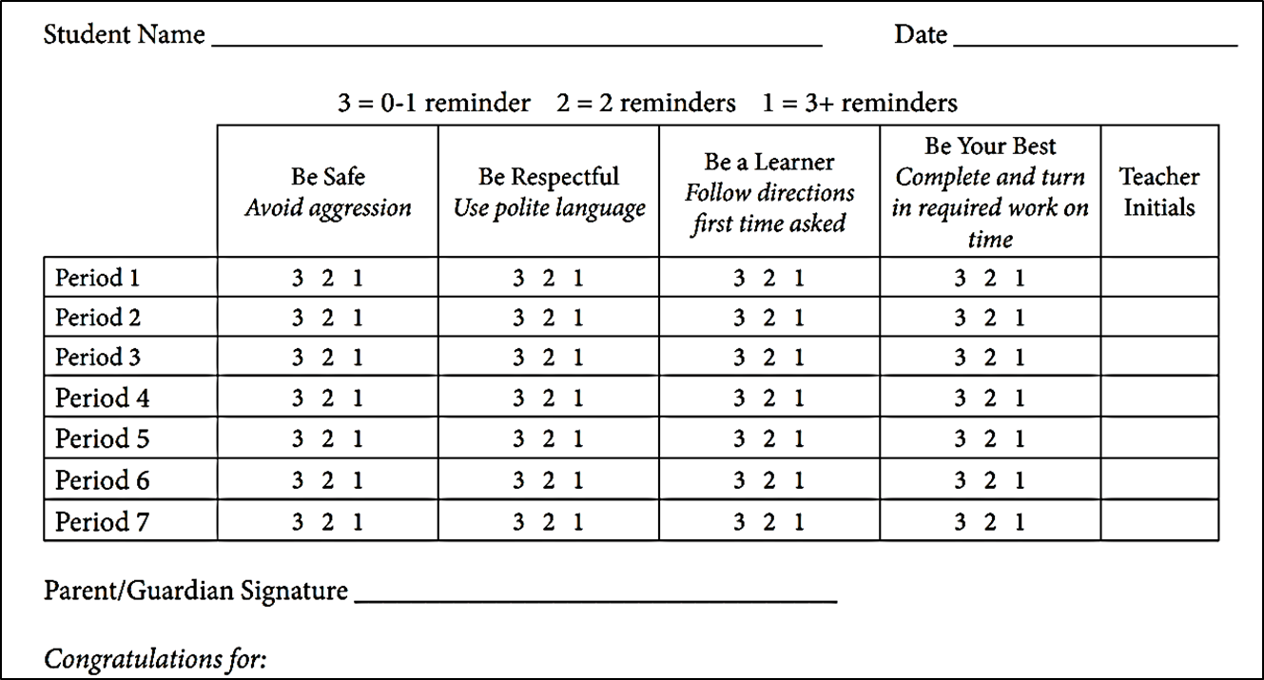
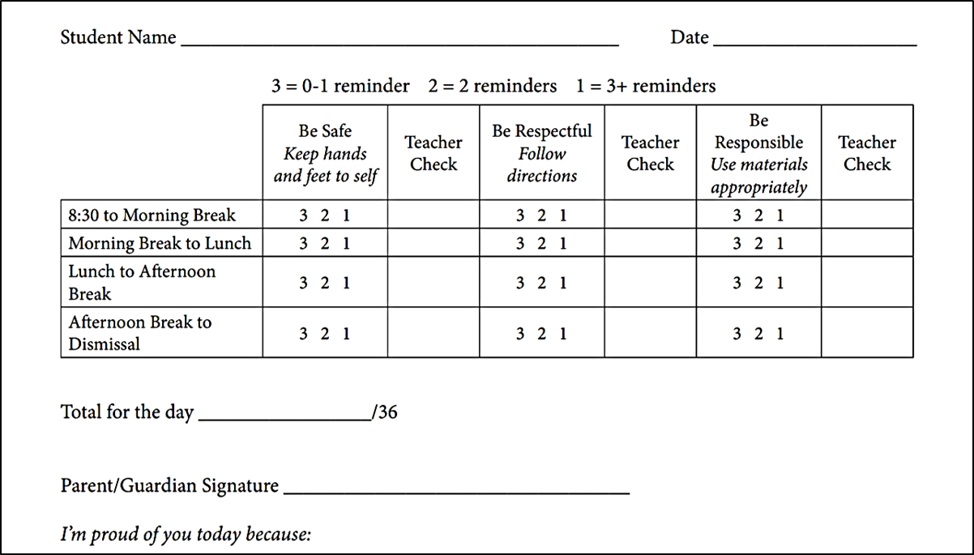
Daily Progress Report example – High School

Daily Progress Report example – Elementary

