
GUIDE TO THESES AND DISSERTATIONS: PROCESS AND FORMATTING
UPDATED SPRING 2026

Introduction
Welcome masters and doctoral candidates. This guide will assist you in completing the thesis and dissertation process. You should read this information closely before beginning to write and research your topic. The information contained in this guide covers Graduate School procedures and general ProQuest requirements; it does not include any processes or requirements specific to individual department or writing style guides. Check with your advisor or graduate program director to confirm that you are completing all the necessary steps towards thesis/dissertation completion. While several individuals are involved in the thesis/dissertation process from prewriting to evaluation, it is ultimately your responsibility to ensure that all aspects of preparation, writing, formatting, and submission are completed.
Included in this guide are two distinct sections:
- Section One covers the preparation procedures required by The Graduate School before you begin writing the thesis/dissertation. Here you will find checklists, links to forms, and all the steps you must complete to begin and end the thesis/dissertation process.
- Section Two covers ProQuest Formatting guidelines for your front matter and document pagination. This will include details regarding the expectations for layout of your document, as well as tips for achieving the proper formatting. There are also video tutorials and workshops included in this section.

Table of Contents
Introduction 1
List of Figures 4
SECTION 1: GRADUATE SCHOOL PREPARTION GUIDELINES AND CHECKLISTS 5
Steps for Completing a Thesis or Dissertation 5
Step 1. Form a Committee 5
Step 2. Writing 5
Step 3. Submitting the Thesis or Dissertation 6
Choosing Between Open Access and Traditional Publishing 8
Publishing and Printing Fees 9
Forms 10
After Submission 11
Completion Checklist 12
SECTION 2: PROQUEST FORMATTING AND ELECTRONIC SUBMISSION 13
Getting Started 14
Front Matter: Title Page, Copyright, Abstract, Dedications, Table of Contents, and Lists 15
Title Page 16
Copyright Page 18
Abstract 19
Dedication/Acknowledgements 21
Table of Contents 22
List of Tables/Figures/Illustrations/Etc. 23
Body Text 24
Chapters 24
Appendices 25
Bibliography/References 26
Footnotes/Endnotes 27
Supplemental Materials 28
Page and Section Breaks 28
How to Change your Page Margins 29
Dot Leaders in the Table of Contents 31
APPENDIX A: PROQUEST SUBMISSION GUIDE 32

List of Figures
Figure 1. Example Title Page 16
Figure 2. Copyright Page Example 17
Figure 3. Example Abstract Page 19

SECTION 1: GRADUATE SCHOOL PREPARTION GUIDELINES AND CHECKLISTS

Steps for Completing a Thesis or Dissertation

Step 1. Form a Committee
- Consult with your faculty advisor or chair of your department.
- Secure the agreement of a member of the graduate faculty to serve as the thesis/dissertation advisor.
  - The dissertation/thesis advisor must complete the request to serve on a thesis/dissertation committee: HERE
  - In the event that the dissertation or thesis advisor leaves A-State prior to completion of the dissertation/thesis, it is the responsibility of the Department Chair, in consultation with the remaining committee members and the student, to appoint another advisor or to assume that position.
- Doctoral dissertations writers should consult with your advisor to form a committee of 3-5 members; master’s thesis writers and your thesis advisor will select at least two additional graduate faculty members to serve on a thesis committee.
  - The committee members must complete the request to form a thesis/dissertation committee: HERE
- Each form should be approved by your Department Chair, the Graduate Program Director, and the College Dean
  - Consult the current Graduate Bulletin to determine the committee structure for the degree sought.
  - The thesis/dissertation advisor will chair the committee.
  - One member of the committee may be from outside the department.

*Both Forms must be approved by your Graduate Program Director, Department Chair, and the College Dean

Step 2. Writing
- Consult with your thesis/dissertation committee members to select a research problem or topic and
  - Complete a thesis/dissertation proposal approval form: HERE
This form must be approved by the thesis/dissertation committee, Graduate Program Director, Department Chair, and the College Dean.
- Once your proposal is approved, consult your thesis/dissertation committee to agree on the writing style manual (MLA, APA, Chicago, etc.) followed throughout your writing process.
  - Note that this style manual applies to the general organization, subdivision of text, and method of source documentation used in the body of the thesis/dissertation.
- Study the Preparation and Electronic Submissions section of this guide. This guide refers to the general organization, formatting, and pagination standards required for submission to ProQuest.
  - While this guide tries to cover all the steps and requirements, these can sometimes change. Direct any questions about formatting, style manuals, or text submissions to your committee chair or the Graduate Coordinator.
- Confirm your submission deadlines. These change each semester but can be found on the campus academic calendar HERE.
  - It is recommended that you submit your document to the Graduate School Graduation Coordinator 3-4 weeks in advance of this deadline.
- Complete the research and study outlined in your thesis/dissertation proposal.
- Prepare the research document in accordance with the Preparation and Electronic Submissions section of this guide.
- Submit your document to the committee. It may take several revisions before the committee approves your document.
- Upon approval of your document by the committee, the advisor completes the thesis/dissertation defense form, HERE
  - This form must be signed by the committee, the Program Director, and the College Dean, then submitted to the Office of the Registrar.

Step 3. Submitting the Thesis or Dissertation
A formatting checklist for each section of your document is included in Part Two of this guide and links to example documents from various areas of study at the end of this guide. To expedite your submission process, review this guide carefully and make sure your work conforms to these guidelines before you visit the submission site. You will be contacted by the Graduate Coordinator once your thesis/dissertation has been reviewed.
The deadline posted on the Academic Calendar reflects the date by which fully approved documents are due. You are encouraged to submit your document as early as possible (we suggest 3-4 weeks) to provide ample time for necessary revisions. The time between initial submission and final approval may also vary due to factors such as proximity to deadlines, projected graduation date, etc. Check your email often for notifications until the document is approved. Delayed revisions on your end will result in a prolonged approval process.
The website for submission is http://www.etdadmin.com/astate and technical assistance can be reached at 1-877-408-5027.

Submission Steps Checklist:
- Create an account on the UMI submission site: http://www.etdadmin.com/astate
- Convert your document to a PDF file.
  - While you can use the UMI file converter up to five times, we recommend converting your file to PDF before submitting. You can save your file as a PDF in Word.
- Agree to the ProQuest/UMI publishing agreement.
- Upload the PDF file and any supplemental files.
  - Acceptable file formats for supplemental files can be found on the UMI requirements page.
  - Although the UMI submission site discusses mailing in documents with very large supplemental files on a CD-ROM, A-State will not accept submission in this manner.
  - Choose whether you would like UMI to file a copyright on your behalf. Keep in mind that there is a charge to copyright.
  - Check with your thesis/dissertation advisor to confirm the required number of document copies to be ordered. The pricing information listed in this document is subject to change.
- After submitting your file to the UMI submission site, email a Word version of your document to the Graduate School Graduation Coordinator. Both documents will be used to check your formatting before approval.
- You will be notified via email if revisions are needed and you must complete all required revisions in a timely manner (usually within 48 hours).

Choosing Between Open Access and Traditional Publishing
What is Open Access?

Open Access means that your document will be freely available for viewing and downloading; dissertations and theses published for Open Access with ProQuest/UMI will be available at no charge for viewing or downloading by anyone with internet access. Sometimes a distinction is made for “limited open access” meaning that material is available free of charge to a limited group of authorized users. Sometimes it is advised that if you are planning to continue publishing or working in your field, or continue your education, select the paid publishing option that allows others to see or find your work, especially in academic settings.

Open access publishing through ProQuest requires a one-time $95 fee. With this option you do not earn royalties.

What is Traditional Publishing?

Traditional publishing at UMI® corresponds with the model that generated the publishing industry as soon as mass-reproduction of printed material was possible. That is, the owner of intellectual property and author of the work contracts with the publisher to reproduce, distribute, and sell copies of the work. The publisher pays the author a certain portion of the revenue thus generated. This is also referred to as the "copy sales and royalty payments" model for ProQuest. It's been ProQuest’s business model since 1938, and they’ve paid out hundreds of thousands of dollars in royalties to the authors of dissertations and theses over the decades. Generally, if you are at the end of your academic career or do not foresee others needing to access your document, you should choose the traditional publishing option.

There is no additional fee for traditional publishing through ProQuest. With this option, you are eligible for royalties.

Regardless of what publishing option you choose, The A-State library has an online and physical collection of all ProQuest published documents that are free to access.

Publishing and Printing Fees
The student is required to pay for two hardcover (8.5x11in) bound copies of their document for the University. This option is a standard library binding and replicates Library of Congress holdings. Both of these copies will be delivered to the library. One is kept in the library collection and the second is delivered to the Committee Chair.

Other than these two copies, you are free to order as many physical copies of your published document as you like, at your own cost. As the author, you will receive the author price discounts versus the researcher or library prices.
More details on copy options are pricing can be found HERE.

Fees listed below are estimates at the time of this guide’s completion and are subject to
change at ProQuest’s Discretion.

Dissertation and Thesis Prices
Traditional Publishing | $0
Open Access Publishing | $95
Copyright Service | $75
Two Required Library Copies | $62 each / $124 total
Student Copy | $38-$62

Forms
The following list of forms should be completed as your complete your degree program. Your degree cannot be conferred if forms are missing. These forms are generally filled out by your committee chair.
All forms can be found in the Graduate School Knowledge Base Shelf or HERE.

- Request to Form Thesis or Dissertation Committee
- Request to Serve on Thesis or Dissertation Committee
- Comprehensive Exam Results
- Submission of Thesis or Dissertation Proposal
- Thesis or Dissertation Defense

If you require a time extension, accelerated credit transfers, or need to change a committee member, these forms are also included in the Graduate School Knowledge Base Shelf.

After Submission
After you submit your document and all edits have been approved, the Graduate School Graduation Coordinator will make sure your format is approved in ProQuest. Your final document will not be approved for publication until after degrees are conferred by the Registrar’s Office.
Once approved, you will receive an email from ProQuest/ETD Administrator stating that your document was accepted and will be released to ProQuest for publication. After this point, the copies you ordered for the library and personal copies will be printed and shipped. This usually takes between 4-6 weeks. If you ordered personal copies, you will be notified via an email from ProQuest that your copies are being shipped. If you do not receive an email, you can contact ProQuest directly.

Completion Checklist

- Select a committee chair and ask to serve
- Construct a committee
- Request to Serve on Committee FORM
- Request to Form Committee FORM
- Thesis/Dissertation Proposal FORM
- Select style manual
- Complete research and writing
- Obtain committee approval for defense
- Defend your thesis/dissertation
- Thesis/Dissertation Defense FORM
- Comprehensive Exam FORM
- Send document to Graduate School Graduation Coordinator for edits
- Submit to ProQuest
  - Purchase required 2 copies and any personal copies
- Email word doc version of document to Graduate School Graduation Coordinator for review
- Doctoral students complete the National Science Foundation’s Survey of Earned Doctorates: https://sed-ncses.org/login.aspx
- Degree conferred
- Document accepted for publication
- If you ordered personal copies, they are usually delivered within 4-6 weeks after document is accepted for publication.

SECTION 2: PROQUEST FORMATTING AND ELECTRONIC SUBMISSION

Introduction

This section of the Thesis and Dissertation Guide covers ProQuest Formatting guidelines, including detailed layout expectations for your document, and tips for achieving the proper formatting in Microsoft Word.

At this stage, a clear distinction must be made between the publication formatting required by ProQuest and the style manual conventions selected by you and your committee.
Section One of this guide directs students to speak with their thesis/dissertation committee to determine the appropriate style manual to use while writing their text. The formatting described here, in Section Two, refers specifically to the ProQuest formatting requirements for the overall document. The ProQuest publication formatting dictates the margins, pagination, cover page, and introductory portions of your document. Your selected style manual will help determine the general organization, specific subdivision of the text, and the method of source documentation to be used. In other words, your style manual covers everything from the title of your first chapter to the last entry in your references/bibliography page, while the ProQuest formatting applies to everything else.

In scenarios where your selected style manual and the ProQuest guidelines conflict, follow the ProQuest guidelines.

Writers may be advised to review other theses or dissertations in their field during their writing process. While this is an excellent tool for modeling the discourse that other scholars in your field value, The Graduate School does not recommend using another thesis or dissertation as a model for ProQuest formatting or source documentation because a previously published text may not be up-to-date in these specific areas. We’ve included supplementary materials throughout this guide where we link out to theses and dissertations from various disciplines written by previous A-State students: these are up-to-date at the time of this guide’s completion in Spring 2026.

If your research involves human subjects, you will likely need to complete the IRB training through CITI. Confirm this step with your advisor as needed.

Getting Started
Apart from Mathematics majors, it is strongly recommended that you do not complete your work in any software other than Microsoft Word, as the downloading process often shifts your formatting. This guide will only refer to Microsoft Word when describing how to achieve specific formatting. Before you write, you should check that the font, line spacing, margins, and pagination settings are correct in your Microsoft Word settings. This is where most writers encounter formatting mistakes. Never trust the default settings. Below, we have listed the settings that remain the same throughout the document.

Consistent Formatting:
- Left and right margins 1.25’’
- Bottom margin 1’’
- Line spacing 0’’ before and after
- All pagination is centered in the footer (title page number is suppressed)
- All section and chapter titles are in ALL CAPS, centered, not bolded or italicized, and start a new page

Please note that there is a difference between “space” and “inches”. “Space” refers to starting a new line of text using the return or enter buttons on your keyboard (“double space” means an empty line between lines of text). “Inches” refers to the true measurement of the empty areas between information. Pressing “enter” and hoping you are close will not get the spacing you need. For more detailed tutorials on ProQuest formatting, see the A-State Writing Center.

Some sections will require changes in the top margin and pagination will change from lower case Roman numerals (i, ii, iii, iv, etc.) to Arabic numerals (1, 2, 3, etc.).

To achieve this, you will need to create section breaks between these sections. You can find more details about section breaks in this guide’s Supplemental Materials section.

Overall, your document should have the following sections, in this order:

- Title Page
- Copyright page (optional)
- Abstract
- Dedication and/or Acknowledgements (optional)
- Table of Contents
- List of Figures/Tables/Illustrations/Symbols
- Document Content: Chapters with introductions and main body
- Appendices
- Bibliography/References

Front Matter: Title Page, Copyright, Abstract, Dedications, Table of Contents, and Lists

Front matter refers to the additional pages before the content of your work. This includes several pieces including the title page, the copyright page (optional), abstract, dedications/acknowledgements (optional), table of contents, and any lists of figures/images/etc. This section is unique because the pagination is in lower case Roman numerals instead of Arabic numerals, and the pagination on the title page is not visible.

This section will go over each page of front matter and its correct ProQuest formatting for publication.

Title Page
The title page contains all the identifying information for your text, including your title, name, institution, names of your committee members, and the date of publication.
Below is a sample title page. There is also a title page template located within the Graduate School Knowledge Base Shelf.

Formatting Checklist
- Top margin 2’’
- Left and right margin 1.25’’
- Bottom margin 1’’
- Center all text on this page
- Center TITLE in all caps
  - If the title is more than one line, it should be double spaced
- Insert 1 inch blank space (72 points in the Layout Tab)
- Your name
- Insert 1 inch blank space (72 points)
- Type the University statement
  - “A Dissertation (or Thesis) presented to the faculty of Arkansas State University in partial fulfillment of the requirements for the Degree of ……
    - Make sure this is single spaced
- Insert 1 blank line
- Title of Degree, in ALL CAPS
- Insert 1.5-2 inches of blank space (48 points)
- Add ARKANSAS STATE UNIVERSITY
- Add month and year of graduation
- At the bottom of the page:
  - Approved by: followed by the committee members names, with your chair first

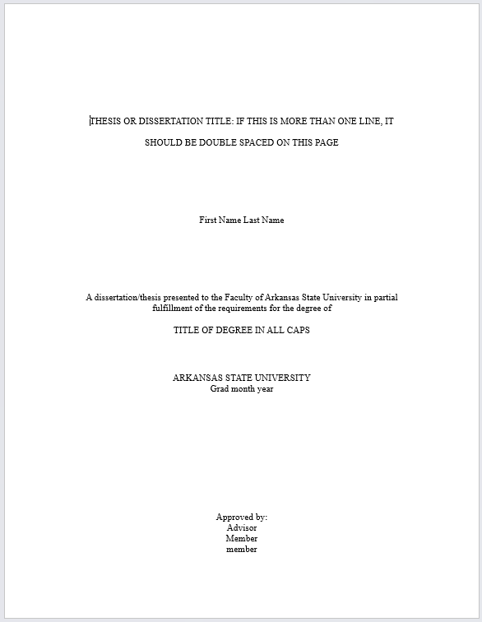
Figure 1. Example Title Page.

Copyright Page

The copyright page is optional. If you have selected to purchase a copyright on your thesis or dissertation, a page to indicate that ownership will follow the title page.

Formatting Checklist
- Left and right margins 1.25’’
- Bottom margin 1’’
- All text centered at bottom of page
- Line one: insert a copyright symbol, followed by the year of publication
- Line two: your full name (exactly as it appears on your title page)
- Line three: ALL RIGHTS RESERVED
- Pagination should be lowercase roman numerals
  - Since the title page, page number is suppressed, the page number here should begin at ii


Figure 2. Copyright Page Example.

Abstract

Abstracts serve as an introduction to your work and will usually appear to other researchers in academic search engines before they access your full text. They typically contain a list of key terms, the main ideas of your text, and a brief description of research methods and outcomes. Abstracts can be no more than 150 words for a thesis or 350 words for a dissertation (not including any lists of key terms).

Formatting Checklist
- Left and right margins 1.25’’
- Bottom margin 1’’
- Top margin 2’’
- Center the word ABSTRACT, USING ALL CAPS
- Insert 1 blank line
- Type your name
- Insert 1 blank line
- Type of title of your document IN ALL CAPS
- Insert 1 blank line
- Begin your abstract
- Pagination should continue lower case Roman numerals from the previous page (iii if you have a copyright page, ii if you do not)

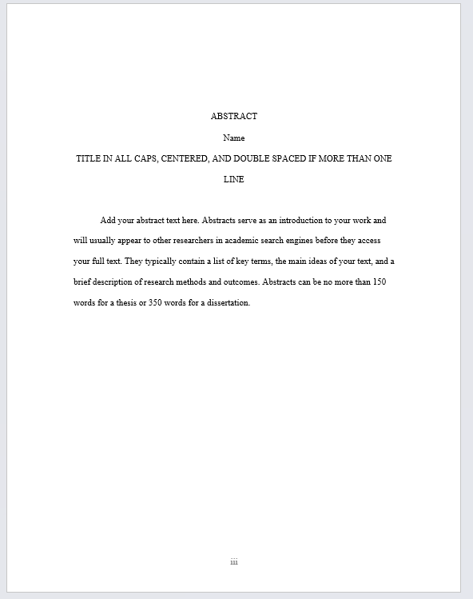
Figure 3. Example Abstract Page.

Dedication/Acknowledgements

These are optional inclusions for both theses and dissertations wherein many writers may choose to show gratitude to people or groups who have supported them in their educational journey. The dedication is an honorific statement from you to a person or group to whom you commend the effort and product of the dissertation. An acknowledgment is a statement of recognition of the people and institutions that helped your research and writing.

Formatting Checklist
- Left and right margins 1.25’’
- Bottom margin 1’’
- Top margin 2’’
  - If your text exceeds one page, all pages after the first should have a 1’’ top margin
- Double space all text on this page
- At the top, center the word DEDICATION or ACKNOWLEDGMENT
- Pagination should continue lower case Roman numerals from the previous page

Table of Contents
The table of contents (ToC) will show the location of major elements of your document. This includes:
- Lists of Tables/Figures/Images/Abbreviations
- Section Headings
  - Chapters, Appendices, References
- Subheadings up to at least the 3rd level
  - You may include more levels but must be consistent in style and this choice
You can either manually type a ToC or use the “Insert Table of Contents” tool in Word; this is found in the REFERENCES tab at the top. Word will give you several choices, including a manual version in which you type your own page numbers versus Word putting them in for you.

Formatting Checklist
- New Page top margin 2’’
- Left and right margins 1.25’’
- Bottom margin 1’’
- Center title TABLE OF CONTENTS
- Insert one blank line
- Headings that are longer than one line should be single-spaced
- Each entry on the table should have a blank line between it and the next entry
- Page numbers for the ToC should be aligned on the right margin
- Pagination continues the lowercase Roman numerals from the previous page
- All pages of the ToC after the first page, start with a top margin 1’’. This is done by inserting a Continuous page break after the first page, and then changing the margin on the second page. This will automatically carry though the rest of the document until you insert a new section break.
- Make sure all headings and subheadings are spelled, capitalized, and punctuated EXACTLY as they are in the body of your document, EXCEPT do not use bold or italics (this does not apply to medical or biological terms that are always italicized)
- Make sure all font styles and sizes match the rest of your document (usually this is Times New Roman 12)
- For help with dot leaders in the ToC, refer to the Supplemental Materials section

List of Tables/Figures/Illustrations/Etc.
These sections serve as guides to the tables and figures that will appear throughout the body of your text so readers are able to find what they need, quickly. You can also use this for symbols, abbreviations, etc. that appear throughout your work. The tables/figures/illustrations themselves do not appear here, but simply a listing of their titles and page numbers, similar to the Table of Contents previously seen.

Formatting Checklist
- New Page top margin 1’’
- Left and right margins 1.25’’
- Bottom margin 1’’
- Center title TABLE OF LISTS/TABLE OF FIGURES/TABLE OF ETC.
- Insert 1 blank line
- Each list must start on its own new page. You cannot combine your list of tables and the your list of figures.
- Assign each table/list/illustration/etc. with its own Arabic numeral that is consistent throughout
  - Table 1, Table 2, Table 3, etc.
  - Table 3.1, Table 3.2, Table 4, Table 4.1, Table 4.2, etc.
- Pagination continues the lowercase Roman numerals from the previous page
- Remove any bold or italic font (except medical or biological terms that are always italicized)
- Use dot leaders, exactly like the Table of Contents, that align on the right margin

Body Text

Chapters
Theses and dissertations should be divided into chapters. These chapters may include an introduction before the main body. The main body of your text will be divided, when needed, by consistent subheadings. Your chapters should all maintain a consistent style (font, size, etc.) throughout the entire document, including the headings and subheadings.

Formatting Checklist
- New Page top margin 2’’
- All pages, after the first page of each chapter, start with a top margin 1’’. This is done by inserting a Continuous page break after the first page and then changing the margin on the second page. This will automatically carry though the rest of the document until you insert a new section break.
- Left and right margins 1.25’’
- Bottom margin 1’’
- Center title CHAPTER I (or 1): CHAPTER TITLE
  - Main section titles cannot be bold or italicized
  - Chapter titles are centered and always typed in ALL CAPS
  - Other subheadings adhere to your chose style manual (these can be bolded or italicized)
- Insert 1 blank line
- The main body of the document is double-spaced
  - Exceptions: block quotes, notes, captions, legends, and long headings are all single spaced
- Indent all paragraphs consistently (generally 1 TAB key)
- All text remains the same size, 12 pt; headings or subheadings are never larger or smaller than the body text
- Pagination is centered at bottom of the page, using Arabic numerals (1, 2, 3)
  - The first page of your document beings Page 1
  - All other pages continue this pagination

Appendices
The appendices/appendix will appear at the end of your document. This is different from the list of tables/figures/etc. as it contains material not included in the body of the text (similar to endnotes) that support your document. It should be the final chapter of your document before your bibliography. It may include items such as other figures, emails, correspondence, images, or other forms of data incorporated or mentioned within the body of your document.

Formatting Checklist
- New Page top margin 1’’
- Left and right margins 1.25’’
- Bottom margin 1’’
- Center title APPENDIX A, APPENDIX B (depending on how many you have)
  - You may chose to use letters or a number and should include a descriptive title
  - Title should be in ALL CAPS, no bold or italics
- Each appendix begins on a new page
- Pagination continues the Arabic numerals from the previous page

Bibliography/References
The bibliography is the master list of all reference material consulted in the composition of the final document. You are required to and ethically responsible for documenting your sources. The formatting of your bibliographic entries will depend on the selected style manual you use for your document. Bibliographic citations can vary from one style to next, so consistency is of the utmost importance. The titles of this section (i.e. bibliography, works cited, references, sources consulted, etc.) should be determined by you and your committee chair and can vary between your discipline and designated style manual.

Formatting Checklist
- New Page top margin 1’’
- Left and right margins 1.25’’
- Bottom margin 1’’
- Center title BIBLIOGRAPHY/WORKS CITED/Etc.
  - Title should be in ALL CAPS, no bold or italics
- All entries should be single spaced, with a blank space between each
- Keep font and size consistent with the rest of the document
- Avoid widows/orphans
  - Widow: isolated line at the top of a page
  - Orphan: isolated line at the bottom of a page
  - Each page should being with a whole citation and end with a whole citations, do not split a citation between two pages
- Pagination continues the Arabic numerals from the previous page

Footnotes/Endnotes
Footnotes and/or endnotes are used to reference or cite information without breaking up the flow of the text. Endnotes are footnotes that appear either at the end of the chapter or the end of the body of the text, but before the bibliography. Footnotes will follow a consistent style determined by the manual you and your committee select for your thesis. Footnotes are acknowledged by a superscript Arabic numeral within the text. Footnotes can appear either at the end of each page, the end of the chapter, or the end of the text, depending on how you utilize them.

Formatting Checklist
- Determine whether you will include footnotes or endnotes
  - Footnotes appear at the end of the page they are inserted, in the main body
  - Endnotes appear at the end of each chapter, in the main body
- Font type and size should remain consistent (the standard is 2 points smaller than the main text, followed by a period)
- Footnotes at the end of a page will adjust in Word automatically
- Endnotes should being on a new page at the end of the chapter
  - Top margin 1’’
  - Bottom margin 1’’
  - Left and right margin 1.25’’
  - Begin page with a new heading, “Notes”

Supplemental Materials

Page and Section Breaks
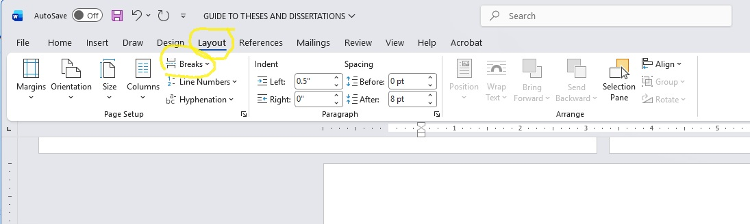
There are 7 types of page and section breaks. These are located under the “LAYOUT” tab at the top of Microsoft word.

The most important breaks you will need are: page break, next page section break, and continuous section break.
The page break, when inserted, will mark the point one page ends and the next begins. The next page section break will insert a new page and begin a new section on the next page. You can use this to start a new chapter or to move text to the next page. The continuous section break will start a new section but not insert it on a new page. You can use this section break to change the top margins of your document.

How to Change your Page Margins
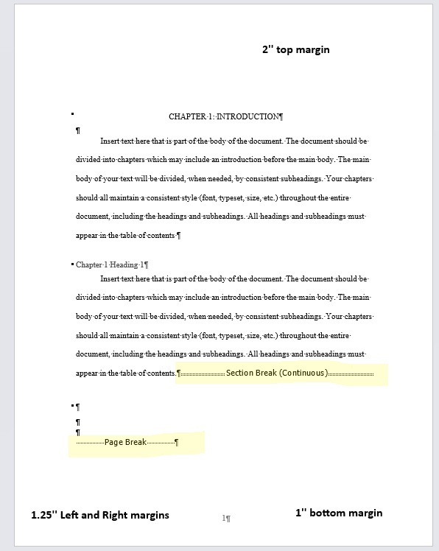
In the body of your text, the first page of each chapter begins with a 2’’ top margin and every page of that same chapter afterwards begins with a 1’’ top margin. To create this you must use the continuous section break.
Step 1. At the end of your first page of your chapter (make sure the top margin formatting and all other margins are correct first), click after the last word on the page.
Step 2. Insert a continuous section break. Sometimes this adds an extra line to the next page, make sure to delete this extra line.
Step 3. On the page after your continuous section break, change your top margin settings to 1’’. It should change your margins for the rest of the document section to 1’’ and leave the first page with a 2’’ top margin.

If you need further help, view this video or visit the Theses and Dissertation Youtube page.

Dot Leaders in the Table of Contents
To ensure that your Table of Contents (ToC) is formatted correct and easy for readers to follow, it is required that your ToC uses dot leaders between the table entry and the page number.
You can set these up in Microsoft Word using the tab stop and style functions in the main menu.
Step 1. Select the text you would like to apply the dot leader to.
Step 2. In the HOME tab in Microsoft Word, click the Paragraph group to open the dialog box. In the INDENTS AND SPACES tab, click TABS at the bottom left to open the tabs options.
Step 3. At top, click the “Tab Stop Position” text area and type the tab position. Select your alignment and choose a leader option. Click SET to apply these changes and a new tab stop will appear in the menu.
Step 4. Once you click OK and close the box, the tab position will appear on the ruler and leaders will be applied to your ToC.

If you need further help, visit this video or visit the Theses and Dissertations Youtube page.

APPENDIX A: PROQUEST SUBMISSION GUIDE
ProQuest- Submission Instructions
- Enter ETD Website (https://www.etdadmin.com/) Create your account.
- At the top, blue banner, click “Create New Submission”
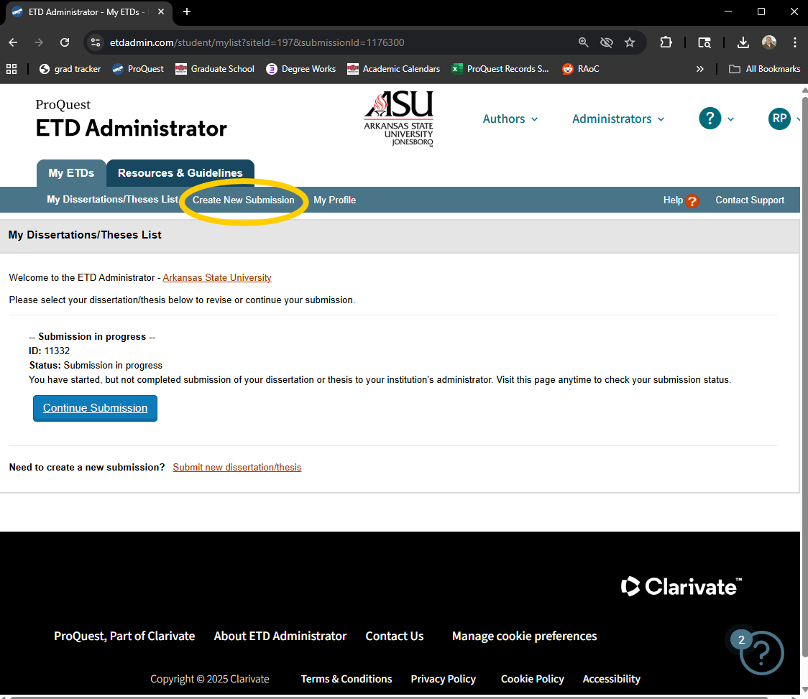

- Complete steps on left side of screen. ProQuest will walk you through each step.
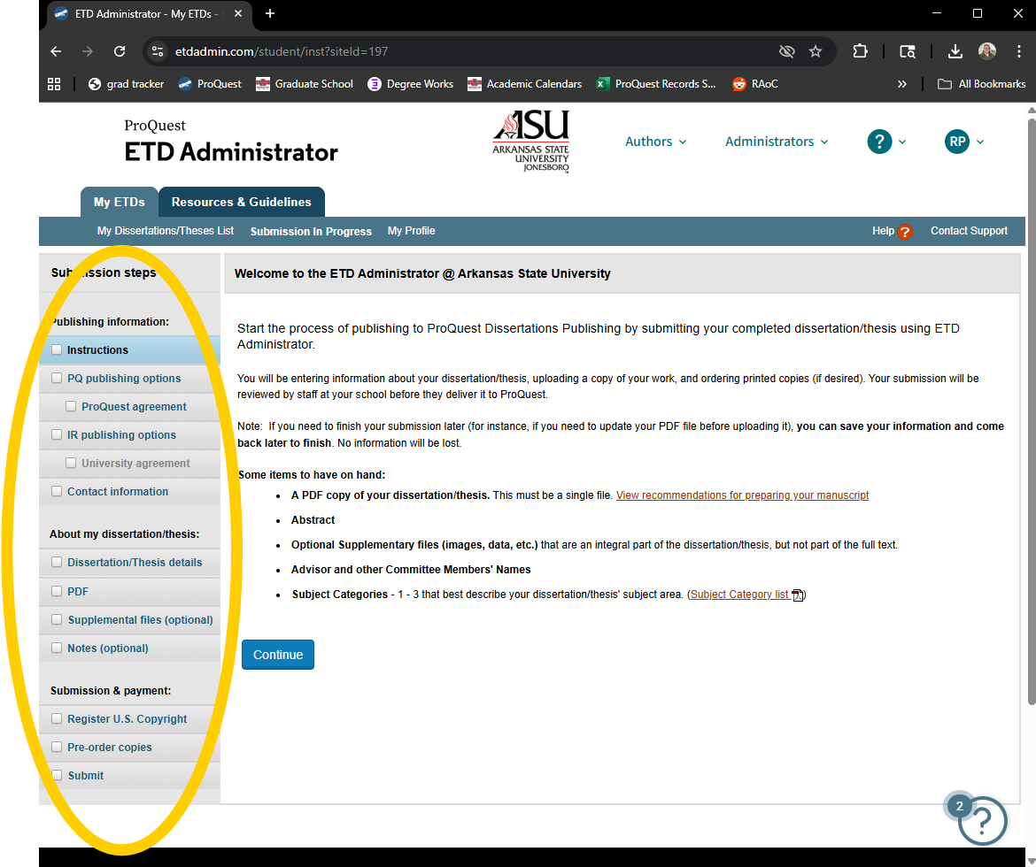

- PQ Publishing Options:
PQ offers two publishing options—one free and one paid. We advise that if you are planning to continue publishing or working in your field, or continue your education, select the paid publishing option. This allows others to see and find your work, especially in academic settings.

If you are at the end of your academic career or do not foresee others needing to access your document, we suggest you choose the traditional publishing option.
The A-State library has an online and physical collection of all ProQuest published documents that is free to access.
- In your contact information, make sure to use an email that you will have access to regularly. This is the email that official ProQuest publishing information will come through, as well as editing emails from the Graduate School.
- Copyrights are not required. If you choose to add a copyright to your document, there is an additional fee.
- You are required to purchase copies of your document. You must purchase at least 2 hardbound copies for the Library depository, and one for yourself, in whatever binding you choose. Make sure to verify what copies you need with your program director; some programs require copies for the committee chair and program director.
  - Currently, the hardbound copies (8.5x11in) are $62 each, for a total of $124
  - You can also return to the site later and purchase additional copies.
- Once your payment processes and you submit your document, you will receive an email confirming.
*your submission will not be complete unless you pay for your copies/copyright/publishing.

