Starting your syllabus: Navigate to a specific course in your Canvas and click on the Simple Syllabus link. The syllabus editor will open inside of Canvas. OR navigate to your school’s Simple Syllabus site directly and work from your Dashboard.
Completing your syllabus: To complete your syllabus, be sure you’ve addressed all required components. Required components will include an orange outline around the box and show as required in the bottom left corner. For components that use a pencil icon, look for an asterisk to denote a required field… and be sure to click save! Until you complete all required components, the submit button will remain gray and unclickable.
Copy and paste: For best results with formatting, it’s recommended to type new content into your syllabus instead of pasting. We recommend using the built-in editor to select not just your font, but also the size, color, style, and spacing options. Pasting content can result in unpredictable formatting and reduced accessibility.
Printing your document/downloading PDF: Once your document is complete, you will be able to View, Print and Share.
- View: To view a digital version of a syllabus click the View button.
- Download or Print: To download or print a PDF version of a syllabus, click the Print button. You can then either choose to download the document or send it to a printer.
- Share: To share a digital version of the syllabus, click the Share button. From there you can choose to copy the syllabus URL or syllabus PDF URL.
Uneditable components: Some components cannot be edited at the Instructor level. Administrators establish editing rights for specific components on a template handled at the institution level. If you can edit some components but not others, this is likely by design.
Updating your integrated schedule component: If you are seeing incorrect or outdated items in your schedule component, you need to adjust these items in your Canvas.. Once Simple resyncs (which takes place daily), these assignments will be updated.
If your schedule component does not display the updated content, the connection between Simple and your Canvas may have been broken by a user edit. Depending on your site settings, you may be able to utilize the Reset feature if you would like to completely re-sync the schedule component. Look below for instructions on how to Reset a component.

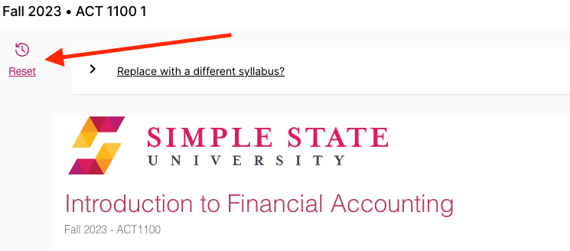
Resetting a component: Resetting a component reverts the content in that component to the content feeding in from a template, the SIS, or LMS. Published documents in the library will still contain the existing/old content until the new version of the document is fully resubmitted. Resetting will only remove manual edits made in the component that is being Reset, not the entire document. Clicking the Reset button will open a left overlay, allowing editors to choose which components they would like to reset.
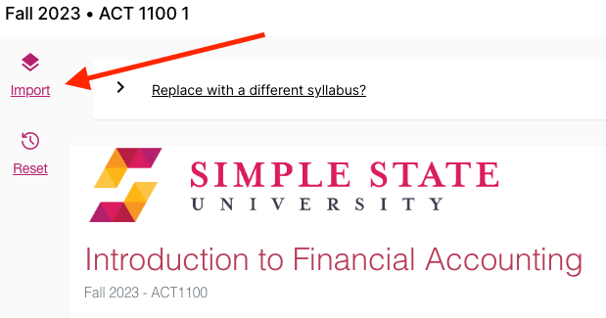
Import content into your syllabus: These settings may not be enabled by your administrator. If they are, you can import existing content by utilizing these features:
Replace with a different syllabus: This feature will allow you to see previous documents you were assigned in Simple. Using the Search and Filter tool, find your previous syllabus by selecting the appropriate term from the term drop-down list or by using the keyword search bar. Click on the syllabus and begin your import. After the import is complete, make any changes or updates relevant to the new section and click Submit. This feature will only display your previous documents.
- Full Import tool: This feature allows you to import from any document within Simple. Clicking the Import button will allow you to select the term, subject, course number and section number of the document you are trying to import. For a more specific import, you can also select which components you would like to copy over by clicking the Advanced button.
Uneditable components: Some components cannot be edited at the Instructor level. Administrators establish editing rights for specific components on a template handled at the institution level. If you can edit some components but not others, this is likely by design.
Error message upon opening course: Check to ensure third party cookies are enabled. If they are, please reach out to support at help@simplesyllabus.com and include a screenshot of the error message. Be sure to click the More Details button (if present) and include all relevant details in your screenshot.

When to contact your school Admin:
- Missing course: You’re missing a course from your Simple Syllabus dashboard. This course will need to be added via your LMS or through the files sent to Simple by your admin.
- Remove course: You want to remove a course from your dashboard. This course will need to be removed from your LMS or in the files sent to Simple by your admin.
- Missing account: You receive an error that says, “Sorry, we could not locate a matching account in Simple Syllabus.” Your account will need to be added to Simple by your admin via your LMS or in the files sent to Simple.
- Missing data points in Syllabus (E.G. course description, office hours, etc): Populated data sent to Simple from your SIS will need to be altered by your admin. For more information on the data that automatically populates your document, read this article on block data.

